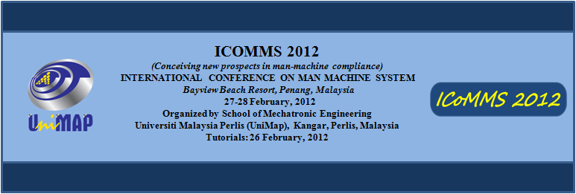REGISTRATION FORM
ICoMMS 2015
(conceiving new prospects in man-machine system compliance)
INTERNATIONAL CONFERENCE ON MAN MACHINE SYSTEMS
Penang, Malaysia
30-31 March, 2015
Organized by School of Mechatronic Engineering
Universiti Malaysia Perlis (UniMAP), Arau, Perlis, Malaysia

ICoMMS 2015

Please complete this form and return it by e-mail to icomms2015@unimap.edu.my OR icomms2015@gmail.com

Paper ID : ______________________________________________________________
Paper Title : ______________________________________________________________
___________________________________________________________________________

PARTICIPANT’S INFORMATION

Name :______________________________________________________________
Title :Prof. Dr. Mr. Ms. Mrs. Others:________________
Affiliation :______________________________________________________________
Address :______________________________________________________________
___________________________________________________________________________
Postal code :______________________________________________________________
City :______________________________________________________________
Country :______________________________________________________________
Telephone :______________________________________________________________
E-mail :______________________________________________________________

MISCELLANEOUS
Special needs :Vegetarian Wheelchair Others:_______________________________

BIOGRAPHY FOR ORAL PRESENTATION
(To be used by Session Chairman while introducing the presenting author to delegates)
Kindly provide a brief biography (you may state qualifications, experiences, research interests etc.)
Maximum 100 words:

I hereby certify that all of the information given above is true.

…………………………………………………………………………………………………..
(Signature)
Name : ______________________________________________________________
Date :______________________________________________________________

--------------------------------------------------------------------------------
International Conference on Man-Machine Systems (ICoMMS 2015) http://icomms.unimap.edu.my/

